**HTTP Protocol**

Handling Requests, Constructing Responses, HTTP/2 & HTTP/3



**SoftUni Team**

**Technical Trainers**

**Software University**

[**https://softuni.bg**](https://softuni.bg/)



1. HTTP Basics



1. URL
2. HTTP Request
3. HTTP Response
4. MIME and Media types
5. Routing in Web
6. HTTP Dev Tools
7. Web Server
8. HTML Forms
9. HTTP/2
10. HTTP/3 2

# sli.do



#csharp-web

3



## HTTP Basics

Basic Concepts



**What is a Protocol? **

* A **communication** protocol == **set of rules**, which define how two or more parties are talking to each other
* It is like a common language used for communication between machines

**Request Response**

**TCP**

**IP**

**HTTP**

**HTTP TCP**

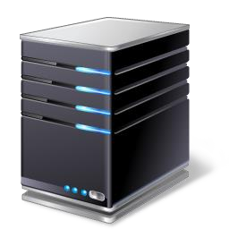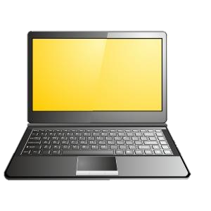

**Media (wires / air /**

**Ethernet**

**Ethernet**

**IP**

**fiber)**

##### **H**yper**T**ext **T**ransfer **P**rotocol



* **Text-based client-server** protocol
* **General-purpose client-server** protocol used to **transmit data**

##### across the web

* + For transferring Web resources (HTML files, images, styles, etc.)
* Relies on **URLs**

##### Stateless



* + Each HTTP request is **independent** from the others
  + Cookies and Web storages can overcome this
* Uses the **request-response model**



**HTTP request**

**HTTP response**

Web Client



Web Server

##### HTTP request

**GET /courses/javascript HTTP/1.1**

**Host:** [**www.softuni.bg**](http://www.softuni.bg/)

**User-Agent: Mozilla/5.0**

***<CRLF>***

**The empty line denotes the**

**end of the request header**

* HTTP response

**HTTP/1.1 200 OK**

**Date: Mon, 5 Jul 2020 13:09:03 GMT**

**Server: Microsoft-HTTPAPI/2.0**

**Last-Modified: Mon, 12 Jul 2014 15:33:23 GMT**

**Content-Length: 54**

***<CRLF>***



**<html><title>Hello</title>**

**Welcome to our site</html>**

**The empty line denotes the**

**end of the response header**



## URL

### Uniform Resource Locator



**Uniform Resource Locator (URL)**

**8080/demo/index.php?id=27&lang=en#slides**

**mysite.com:**

**http://**

**Protocol Host Port Path Query string Fragment**

* URL == formatted string, consisting of
  + **Network protocol** (**http**, **ftp**, **https**...) – HTTP in most cases
  + **Host** or **IP** address (**softuni.org**, **gmail.com**, **127.0.0.1**, **web**)
  + **Port** (the default port is **80**) – integer in the range [**0…65535**]
  + **Path** (**/forum**, **/path/index.php**)
  + **Query string** (**?id=27&lang=en**)
  + **Fragment** (**#slides**) – navigate to some section in the page

**URL Encoding**



##### URLs are encoded according RFC 1738

* Safe URL characters: **[0-9a-zA-Z]**, **$**, **-**, **_**, **.** , **+**, **\***, **'**, **(**, **)**, **,**, **!**

##### All other characters are escaped by

|  |  |  |  |
| --- | --- | --- | --- |
|  | Char | URL  Encoding | |
| space | %20 | |
| щ | %D1%89 | |
|  |  | %22 |
| **SoftUni** | " |  |
| # | %23 | |
| $ | %24 | |
| % | %25 | |
| & | %26 | |

**%[character hex code]**

* + Space is encoded as "**+**" or "**%20**"

**Наков-爱-SoftUni**

* + URL-encoded string

**%D0%9D%D0%B0%D0%BA%D0%BE%D0%B2-%E7%88%B1-**



**Valid and Invalid URLs – Examples**

##### Some valid URLs

[**http://www.google.bg/search?sourceid=navclient&ie=UTF-**](http://www.google.bg/search?sourceid=navclient&ie=UTF-) **8&rlz=1T4GGLL_enBG369BG369&q=http+get+vs+post**

[**http://bg.wikipedia.org/wiki/%D0%A1%D0%BE%D1%84%D1%82%D1%83%D0%B5%**](http://bg.wikipedia.org/wiki/%D0%A1%D0%BE%D1%84%D1%82%D1%83%D0%B5%25)

**D1%80%D0%BD%D0%B0_%D0%B0%D0%BA%D0%B0%D0%B4%D0%B5%D0%BC%D0%B8%D1%8F**

* Some invalid URLs

**Should be**

**?q=C%23+.NET+6.0**

[**http://www.google.bg/search?&q=C#**](http://www.google.bg/search?&q=C) **.NET 6.0**

**%D0%B8%D1%80%D0%B0**

**Should be ?q=%D0%B1**

[**http://www.google.bg/search?&q=бира**](http://www.google.bg/search?&q=бира)



## HTTP Request

### What is a HTTP Request?



**HTTP Request Message**

* Request message sent by a client consists of
  + HTTP **request line**
    - Request method (**GET** / **POST** / **PUT** / **DELETE** / …)
    - Resource URI (**URL**)

**<method> <resource> HTTP/<version>**

**<headers>**

***(empty line)***

**<body>**

* + - Protocol **version**
  + HTTP **request headers**
    - Additional parameters
  + HTTP **request body** – optional data, e.g., posted form fields

**HTTP Request Methods **

* **HTTP** defines **methods** to indicate the desired action to be

##### performed on the identified resource

|  |  |  |
| --- | --- | --- |
| **Method** |  | **Description** |
| GET |  | Retrieve a resource |
| POST |  | Create / store a resource |
| PUT |  | Update (replace) a resource |
| DELETE |  | Delete (remove) a resource |
| PATCH |  | Update resource partially (modify) |
| HEAD |  | Retrieve the resource's headers |

**CRUD == the four main functions of persistent storage**



|  |
| --- |
| **Other Methods** |
| CONNECT |
| OPTIONS |
| TRACE |

##### **GET** is used to request data from a specified resource



* Example of HTTP **GET** request

**GET /index.html HTTP/1.1**

**Host: localhost**

**HTTP request line**

***<CRLF>***

**HTTP request headers**

**HTTP request body is empty**

##### The **POST** method transfers data in the HTTP **body**

* Example of HTTP **POST** request

**HTTP request headers**

**POST /login.html HTTP/1.1 Host: localhost**

**Content-Length: 59**

**Content-Type: application/x-www-form-urlencoded**

***<CRLF>***

**username=testUser&password=topSecret**

***<CRLF>***

**HTTP request line**



**HTTP request body holds the submitted form data**



## HTTP Response

### What is a HTTP Response?

* The **response message** sent by the HTTP server consists of
  + HTTP response **status line**
    - Protocol **version**

**HTTP/<version> <status code> <status text>**

**<headers>**

***(empty line)***

**<response body – the requested resource>**

* + - Status
    - Status

**code phrase**

* + Response **headers**



* + - Provide meta data about the returned resource
  + Response **body**
    - The content of the HTTP response (data)

**HTTP/1.1 200 OK**

**HTTP response** status line

**Date: Fri, 17 Jul 2020 16:09:18 GMT+2**



**Server: Apache/2.2.14 (Linux) Accept-Ranges: bytes**

**Content-Length: 84 Content-Type: text/html**

***<CRLF>***

**<html>**

**<head><title>Test</title></head>**

**<body>Test HTML page.</body>**

**</html>**

**HTTP response**

headers

**HTTP response**

body

##### HTTP response **code** classes



* + **1xx**: informational (e.g., "**100** Continue")
  + **2xx**: successful (e.g., "**200** OK", "**201** Created")
  + **3xx**: redirection (e.g., "**304** Not Modified", "**301** Moved Permanently", "**302** Found")
  + **4xx**: client error (e.g., "**400** Bad Request", "**404** Not Found", "**401** Unauthorized", "**409** Conflict")
  + **5xx**: server error (e.g., "**500** Internal Server Error", "**503** Service Unavailable")

**HTTP/1.1 404 Not Found**

**Date: Fri, 17 Nov 2020 16:09:18 GMT+2**

**Server: Apache/2.2.14 (Linux)**

**Connection: close**

**Content-Type: text/html**

***<CRLF>***

**HTTP response status line**

**HTTP response headers**

**HTTP response body**



**<html><head><title>404 Not Found</title></head>**

**<body>**

**<h1>Not Found</h1>**

**<p>The requested URL /img/logo.gif was not found on this server.</p>**

**<hr><address>Apache/2.2.14 Server at Port 80</address>**

**</body></html>**

##### HTTP **GET** requesting a moved URL



**GET / HTTP/1.1**

**Host:** [**http://softuni.org**](http://softuni.org/)

**User-Agent: Gecko/20100115 Firefox/3.6**

***<CRLF>***

* The following HTTP response (**301** Moved Permanently) tells the browser to request another URL

**HTTP/1.1 301 Moved Permanently Location:** [**http://softuni.bg**](http://softuni.bg/)

***…***

##### The **Content-Type** response header specifies how the output should be processed



UTF-8 encoded HTML page.

Will be shown in the browser.

* Examples

|  |
| --- |
|  |
| Content-Type**: text/html; charset=utf-8** |
|  |
| **Content-Type: application/pdf**  **Content-Disposition: attachment; filename="Report-April-2020.pdf"** |

This will download a PDF file named

**Report-April-2020.pdf**



## MIME and Media Types

### Multi-Purpose Internet Mail Extensions

* [**MIME**](http://en.wikipedia.org/wiki/MIME) == **M**ulti-Purpose **I**nternet **M**ail **E**xtensions



* + Internet standard for encoding resources
  + Originally developed for email attachments
  + Used in many Internet protocols like HTTP and SMTP
* MIME defines several concepts
  + **Content-Type**, e.g. **text/html**, **image/gif**, **application/pdf**
    - Content **charset**, e.g. **utf-8**, **ascii**, **windows-1251**
  + **Content-Disposition**, e.g. **attachment; filename=logo.jpg**
  + Multipart messages (multiple resources in a single document)



|  |  |  |
| --- | --- | --- |
|  | | |
| **MIME Type / Subtype** | **Description** |  |
| application/json | JSON data |
| image/png | PNG image |
| image/gif | GIF image |
| text/html | HTML |
| text/plain | Text |
| text/xml | XML |
| video/mp4 | MP4 video |
| application/pdf | PDF document |
|  | | |

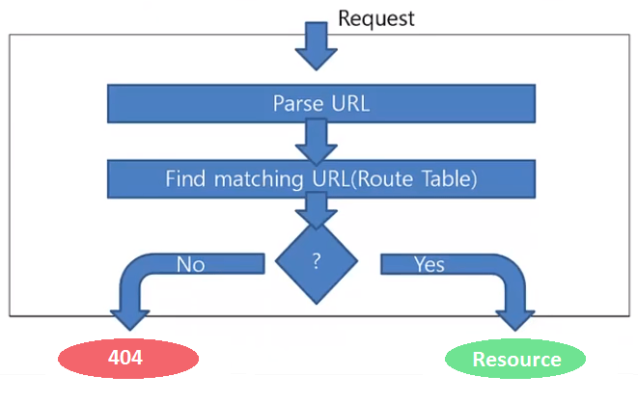

## Routing

Mapping HTTP Request to HTTP Responses

**What is Web Routing? **



* Web Routing is a mechanism where **HTTP requests** are

#### routed to the code that handles them

##### Requests are routed based on the **HTTP**

**request method** and the **request path**



* **HTTP requests** are mapped

#### to HTTP responses

* Example: route "**/**" is often mapped to the app's **Home page**



**Mapping Physical Files**

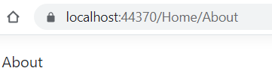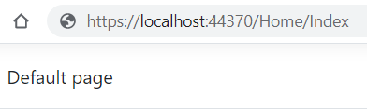

**User-friendly URL replacement of the physical file name**

|  |  |  |
| --- | --- | --- |
| **RouteTable.Routes.MapPageRoute** | | |
| Route Name | Route URL | Physical File Name |
| Home | Home/Index | Index.html |
| About | Home/About | About.html |

**void RegisterRoutes(RouteCollection routes)**

**{**

**routes.MapPageRoute("Home","Home/Index","/wwwroot/Home/Index.html"); routes.MapPageRoute("About","Home/About","/wwwroot/Home/About.html");**

**}**



## HTTP Tools

### Tools for Developers



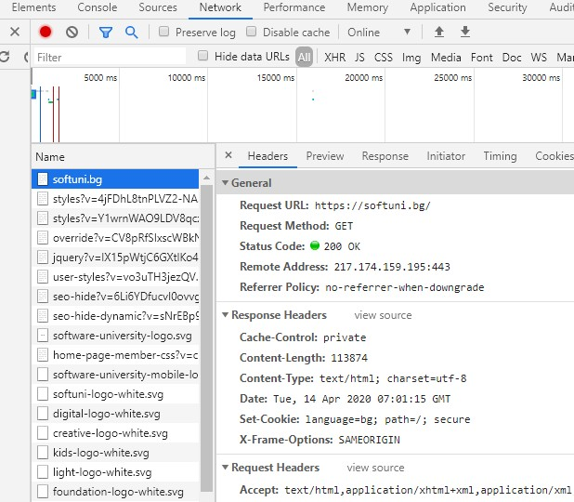 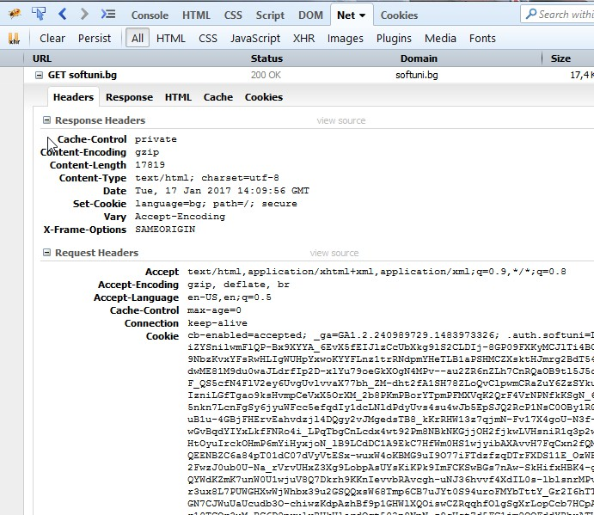

[Chrome Developer Tools](https://developer.chrome.com/devtools) [Firebug](https://addons.mozilla.org/bg/firefox/addon/firebug/)



  

[Insomnia Rest](https://insomnia.rest/) [Postman](https://www.postman.com/downloads/) [RESTClient](https://addons.mozilla.org/bg/firefox/addon/restclient/)

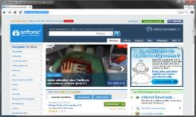

## Web Server

##### Computer system that processes requests via **HTTP**, the basic network protocol

Web Client

Communication

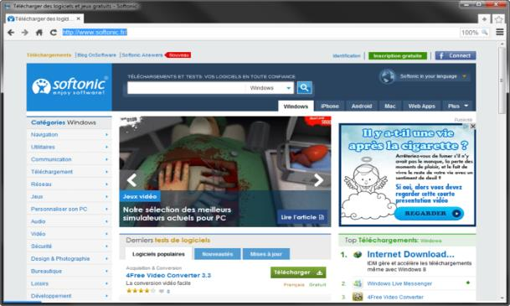

Web Server





Web Client



**http://localhost:8000/softuni.jpg**

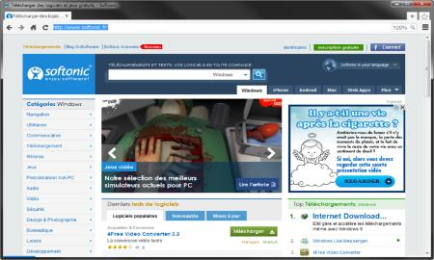

Protocols: HTTP

FTP

WebSocket

Request Protocol

Response

Protocol

Web Server Web Resources

HTML, PDF, JPG…

Host

Port

Resource

URL

Web Client



Request Protocol

Response

Web Server



Web Resources



HTML, PDF, JPG…

Technology

Database





Web Server Technology



Web Resources

HTML, PDF, JPG…

Database



Spring



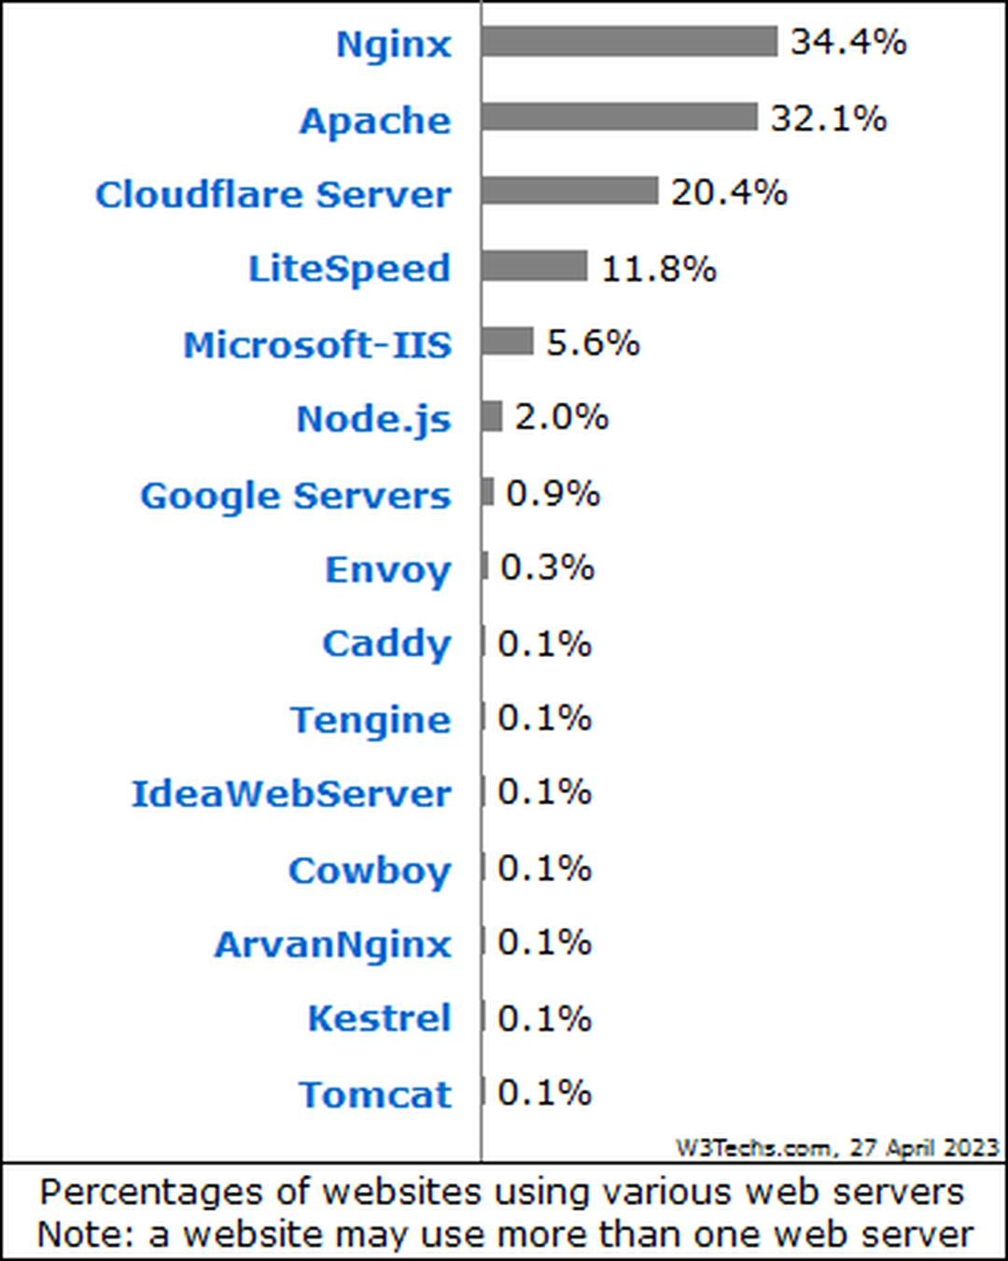 



## HTML Forms

### Form Method and Action

##### Defines

where to submit the form data



**<form action="home.html">**

**<input type="submit" value="Go to homepage"/>**

**</form>**

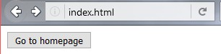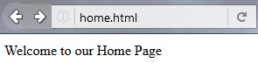

##### ding form data



|  |  |
| --- | --- |
| Specifies the HTTP method to use when sen | |
| **<form action="/" method="get">**  **Name: <input type="text" name="name">**  **<br>**  **<input type="submit" value="Submit">**  **</form>** |  |
|  | |

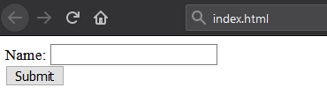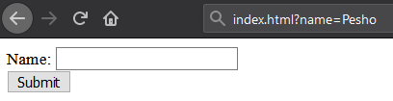

**The form data is in the URL**

**<form action="/" method="post">**

**Name: <input type="text" name="name">**

**<br>**

**<input type="submit" value="Submit">**

**</form>**



**POST** [**http://localhost/index.html**](http://localhost/index.html) **HTTP/1.1 Host: localhost**



**Content-Type: application/x-www-form-urlencoded Content-Length: 10**

**name=Pesho**



**HTTP request body holds the form data**

**<form action="/" method="post">**

**Name: <input type="text" name="name"/> <br/> Age: <input type="text" name="age"/> <br/>**

**<input type="submit" />**

**</form>**

**POST** [**http://localhost/cgi-bin/index.cgi**](http://localhost/cgi-bin/index.cgi) **HTTP/1.1 Host: localhost**

**Content-Type: application/x-www-form-urlencoded Content-Length: 23**

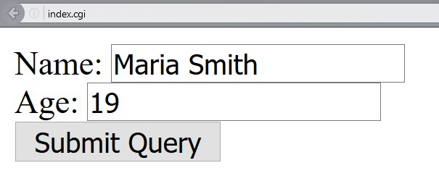

**name=Maria+Smith&age=19**

**File uploads are**

**not supported**

* **GET**



46

* + Values are contained in the **URL**
  + Has a length limitation of **255 characters**
  + It is **often** cacheable
  + Supports only **string data types**
  + Parameters **are saved** in browser history
  + Results **can** be bookmarked
* **POST**
  + Values are contained in the

**message's body**

* + Does **not have** a length limitation
  + It is **hardly** cacheable
  + Supports **different data types**
  + Parameters **are not saved** in browser history
  + Results **cannot** be bookmarked



## HTTP/2

### What's New? What's Better? What's HTTP/2

* **HTTP/2** (originally named **HTTP/2.0**) is a major revision of the **HTTP** network



protocol used by the **World Wide Web**

* + Supported by most of the popular web browsers (Chrome, Mozilla, Opera, ...)
  + Fast & optimized
  + Meets modern web usage requirements
  + Completely Backwards-Compatible
* As of Apr 2023, **40%** of all the websites support **HTTP/2** (W3Techs statistics)
* **HTTP/2** is meant to erase the need of maintaining complex server infrastructures in order to perform well



* **HTTP/2** communicates in binary data frames
* **HTTP/2** introduces several new important elements
  + 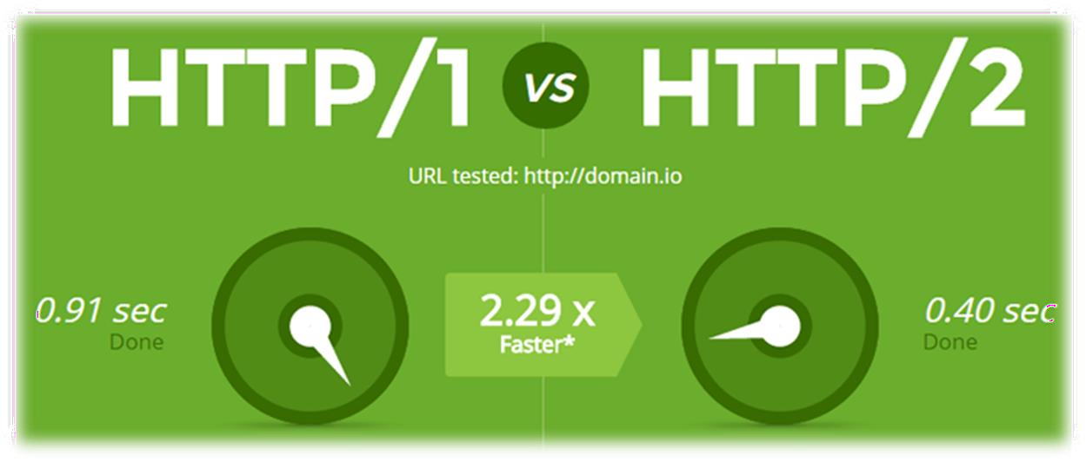HTTP/2 Multiplexing
  + HTTP/2 Header Compression
  + HTTP/2 Server Push
* The art of handling multiple streams over a **single** TCP connection



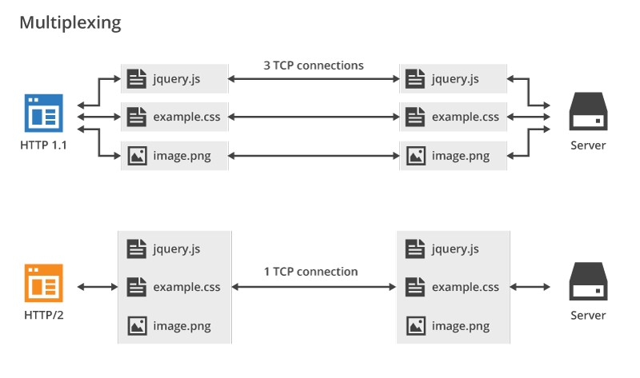



* + **HTTP/2** maintains a **HTTP Header Table** across requests

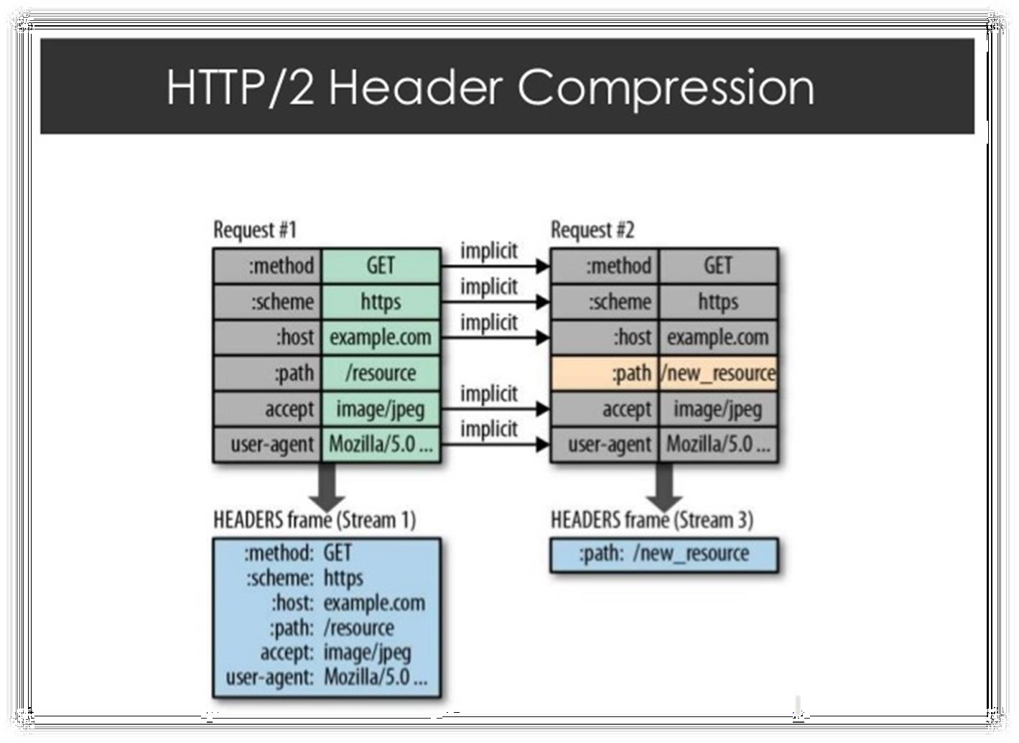

HTTP/2

* + Optimizes communication drastically
  + The process is essentially a **de-duplication**, rather than compression
* **HTTP/2 Server Push ==** the process of sending resources to clients, without them having to ask for it.



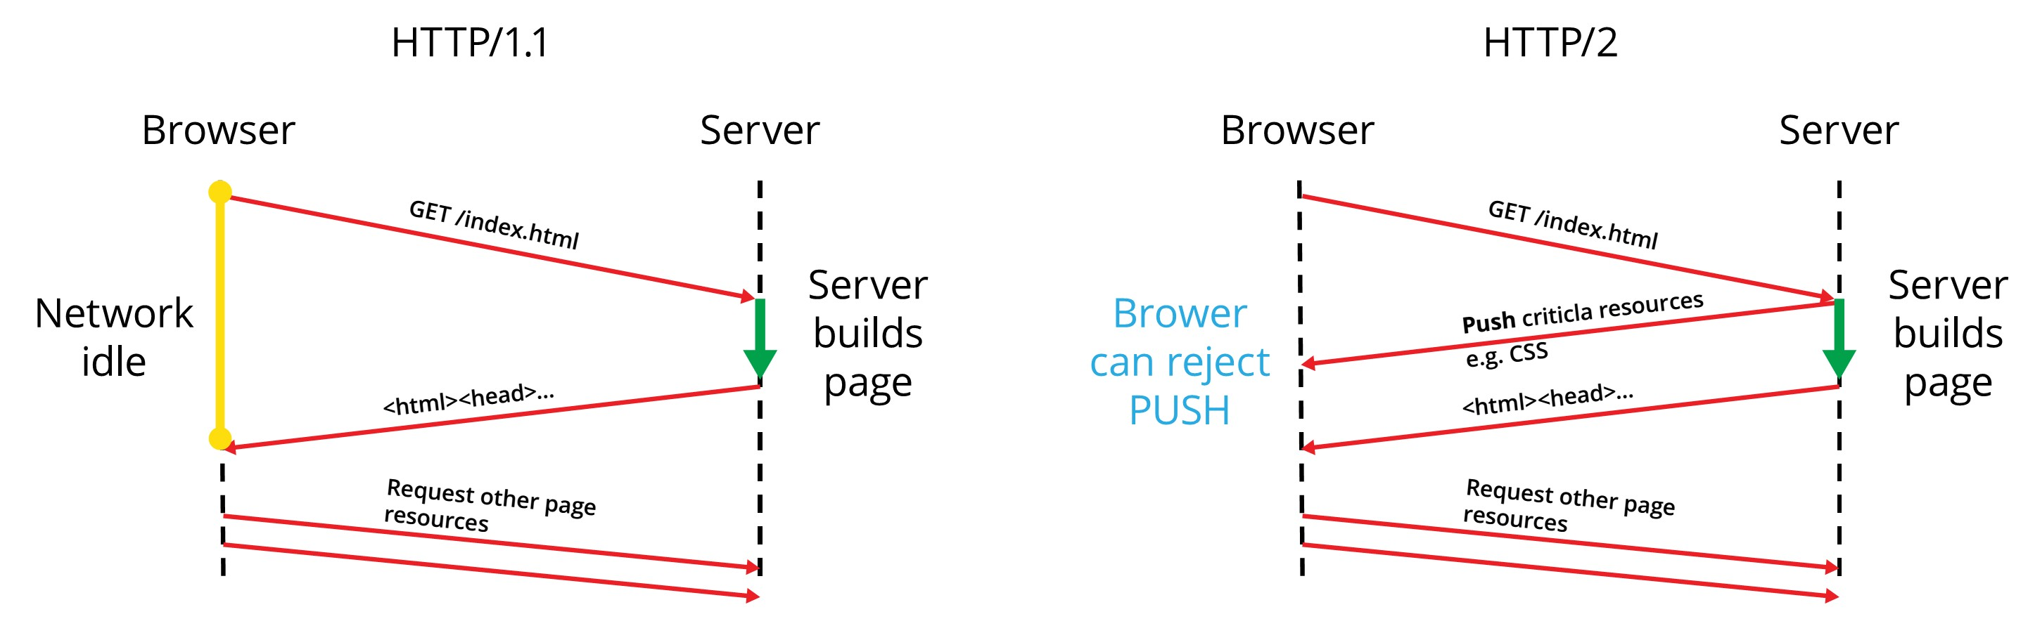



## HTTP/3

### What's HTTP/3



* 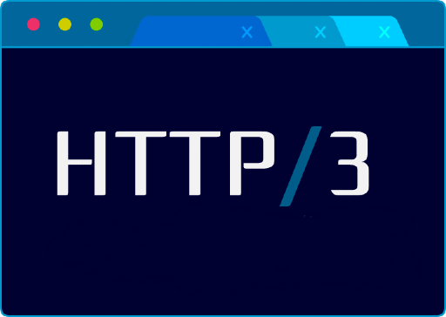**HTTP/3** is a new standard in

development that will affect how web browsers and servers communicate

* As of Apr 2023, HTTP/3 is supported by 26% of web browsers (W3Techs statistics)
* Uses **QUIC** Protocol



* **Significant upgrades** for user

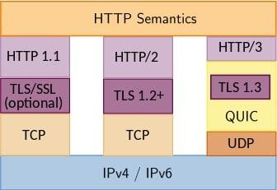experience

* + Decreasing the effects of packet loss
  + Workaround for the slow performance, e. g. when a smartphone switches from Wi-Fi to cellular data
* **Performance**, **Reliability** and

**Security**



* **HTTP**
* ▪ HTML **Forms** & **Actions**
  + **URLs**
  + **Request & Response**
  + **MIME & Media Types**

#### Web Server

* + **Web Communication**





# A picture containing text, sign, vector graphics Description automatically generatedQuestions?







**SoftUni Diamond Partners**



  





##### This course (slides, examples, demos, exercises, homework,

documents, videos and other assets) is **copyrighted content**

##### Unauthorized copy, reproduction or use is illegal

* © SoftUni – <https://about.softuni.bg/>
* © Software University – [https://softuni.bg](https://softuni.bg/)